Question 1 (7 marks)

(a) Part of the graph of  is shown below.

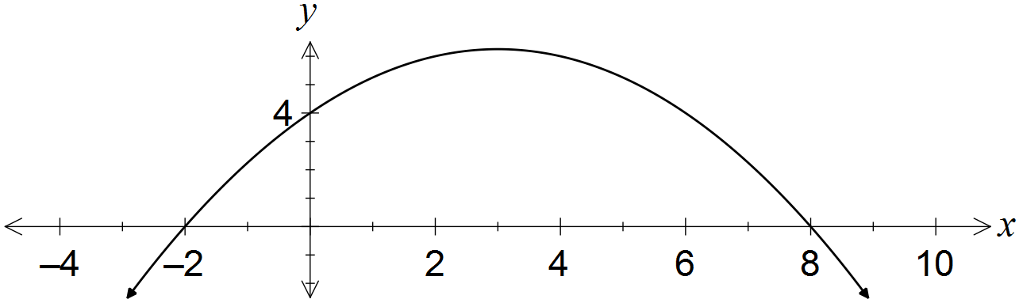

Determine the values of the coefficients a and b. (3 marks)

|  |
| --- |
| **Solution** |
|  |
| **Specific behaviours** |
| ✓ uses roots to express in factored form  ✓ uses y-intercept to find a  ✓ expands and states b |

(b) A quadratic has equation . Determine

(i) the coordinates of its turning point. (2 marks)

|  |
| --- |
| **Solution** |
|  |
| **Specific behaviours** |
| ✓ completes square, or uses x=-b/2a  ✓ states coordinates |

(ii) the exact values of the zeros of the quadratic. (2 marks)

|  |
| --- |
| **Solution** |
|  |
| **Specific behaviours** |
| ✓ uses quadratic formula or completes square  ✓ states both roots in exact form |

(c) Is it possible to bend a 12 cm length of wire to form the perpendicular sides of a right angled triangle with area 20cm? (4 marks)

|  |
| --- |
| **Solution** |
| Height = *x* , Base = *12-x*  *Area: $20$ $=\frac{1}{2}x(12-x)$ $$40=\frac{1}{2}x\left(12-x\right)$$ $$12x-x^{2}-40=0$$ $$x^{2}-12x+40=0$$*  *Discriminant = ${\left(-12\right)}^{2}-4\left(1\right)\left(40\right)$ $= -16 which is <0$*    *There are no real solutions, indicating this situation is impossible.* |
| **Specific behaviours** |
| ✓ Use of $x$ and $12-x$ correctly.  ✓ Substituting into area of a triangle formula  ✓ Correct general formula  ✓ Use of discriminant to indicate no real solutions.  Note: 1 mark if they indicate that they would need two numbers which add to 12 and multiply to 40, 1 mark if they try some values to show that it is not possible, 1 mark if they set out a table in an orderly manner and reach the maximum of 6x6 giving 36 (ie max area is 18sq m)  and 1 mark for demonstrating that this is the maximum by extending the table etc. Basically use your professional judgement and (generously) allocate a mark out of 4 accordingly. |

Question 2 (8 marks)

(a) A circle of radius 5 has its centre at (6, -4).

(i) Determine the equation of this circle. (2 marks)

|  |
| --- |
| **Solution** |
|  |
| **Specific behaviours** |
| ✓ uses standard circle form with correct radius  ✓ correct equation |

(ii) State, with justification, whether the point (9, -8) lies on the circle. (1 mark)

|  |
| --- |
| **Solution** |
|  |
| **Specific behaviours** |
| ✓ substitutes point into equation from (a) and interprets |

(b) Determine the centre and radius of the circle with equation  .

(3 marks)

|  |
| --- |
| **Solution** |
| Hence centre at (2, -3) and radius 2 |
| **Specific behaviours** |
| ✓ factors x terms  ✓ factors y terms  ✓ states centre and radius |

(c) Find the equation of the curve drawn below. (3 marks)

|  |
| --- |
| **Solution** |
| $$y=k\sqrt{x+b}+c$$ $$y=2\sqrt{x+3}-2$$ |
| **Specific behaviours** |
| ✓  ✓  ✓ |

Question 3 (1.1.14) (2, 2, 2 = 6 marks)

A rectangular hyperbola has asymptotes with equation $x=-2$ and $y=4$.

1. Write two possible equations for this function

|  |
| --- |
| **Solution** |
| $y=\frac{a}{x+2}+4$ so a could be any number eg $y=\frac{1}{x+2}+4$ and $y=\frac{-1}{x+2}+4$ |
| **Specific behaviours** |
| ✓✓ two possible equations |

1. Write the equation of this function if it has a *y*-intercept at (0,5)

|  |
| --- |
| **Solution** |
| $5=\frac{a}{0+2}+4$ so a=2 |
| **Specific behaviours** |
| ✓ substitutes correctly into equation  ✓a=2 |

1. Write the equation of this function if it passes through the point (3,5)

|  |
| --- |
| **Solution** |
| $5=\frac{a}{3+2}+4$ so a=5 therefore y $=\frac{5}{x+2}+4$ |
| **Specific behaviours** |
| ✓ substitutes correctly into equation  ✓ states equation |

Question 4 (1.1.24) (1, 2, 1, 2 = 6 marks)

1. Given $f\left(x\right)=x^{2}-2x$
2. What type of correspondence does $f$ show? Circle one of the following.

Many-to-one One-to-many One-to-one

|  |
| --- |
| **Specific behaviours** |
| ✓ Many to one |

1. If the domain of $f$ is $f\left(x\right)∈R, -4≤x≤5$, find the range of $f.$

|  |
| --- |
| **Specific behaviours** |
| ✓✓ 24 |

1. Given $y=2+\sqrt{4-x^{2}}$
2. What is the largest possible value of $y$.

|  |
| --- |
| **Specific behaviours** |
| ✓ 4 |

1. Determine the domain and range.

|  |
| --- |
| **Specific behaviours** |
| ✓  ✓ |

Question 5 (1.1.24) (1, 1, 2, 2 = 6 marks)

Suppose $G\left(x\right)=\frac{2x-3}{x-4}$.

1. Evaluate $G\left(2\right)$

|  |
| --- |
| **Solution** |
| ✓ |

1. Find a value of x such that $G\left(x\right)$ does not exist.

|  |
| --- |
| **Solution** |
| ✓ |

1. Find $G(x+2)$ in simplest form.

|  |
| --- |
| **Solution** |
| $$g\left(x+2\right)=(2\left(x+2\right)-3)/(\left(x+2\right)-4$$ $$g\left(x+2\right)=\frac{2x+1}{x-2}$$ |
| **Specific behaviours** |
| ✓Substitute correctly  ✓ Answer |

1. Find *x* such that $G\left(x\right)= -3.$

|  |
| --- |
| **Solution** |
| $$-3=\frac{2x-3}{x-4}$$ $$x=3$$ |
| **Specific behaviours** |
| ✓Sets equation up correctly  ✓ Answer |